**HIGH LEVEL DESIGN**

**FOR**

**SALES MONITORING SYSTEM**

|  |  |  |  |  |
| --- | --- | --- | --- | --- |
| Prepared by/ Modified by | | Role | | Start Date – End Date |
| Pranjal Chandravanshi | | Team Lead | | 03 Nov 2018 –  22 Nov 2018 |
| Richa Kumari | | SME | | 03 Nov 2018 –  22 Nov 2018 |
| Ekta Bansal | | Point of Contact | | 03 Nov 2018 –  22 Nov 2018 |
| Vaishnavi Sharma, Prerna Sharma | | Designer | | 03 Nov 2018 –  22 Nov 2018 |
| Mishita Juneja | | ETL Developer | | 03 Nov 2018 –  22 Nov 2018 |
| Anish Malik, Kanav Mahajan | | Data Modeler | | 03 Nov 2018 –  22 Nov 2018 |
| Reviewed by | | Role | | Date of Review |
| Visakh Naledath | |  | |  |
| Approved by | | Role | | Date of Approval |
| Arun Ragul | |  | |  |
| Circulation List | To all the ELTP mentors and the applicable trainee teams | | Version number of the template | V1.0 |
| **Version number of the work product** | V1.0 | | | |

**TABLE OF CONTENTS**

* 1. Introduction..............................................................................................................................1
  2. High Level Architecture.............................................................................................................2
  3. Schema Design..........................................................................................................................3
  4. Reporting...................................................................................................................................4
  5. Risk & Assumptions...................................................................................................................5

References

**1. INTRODUCTION :**

This Document outlines the High Level Design for the PLP “Sales Monitoring System” for the BI LOT. The project is to design the dataware house, reports and queries related to Sales Monitoring System. This document contains Design of Dimensional model, Schema structure and Report and related high level details.

Heterogeneous Sources i.e. operational data (Flat files)

EXTRACT

TRANSFORM

LOAD

Data warehouse (Oracle)

Reports Based On Universe

UNIVERSE

(Ab Initio)

(BO IDT)

(BO XI Rich WebI/WebI)

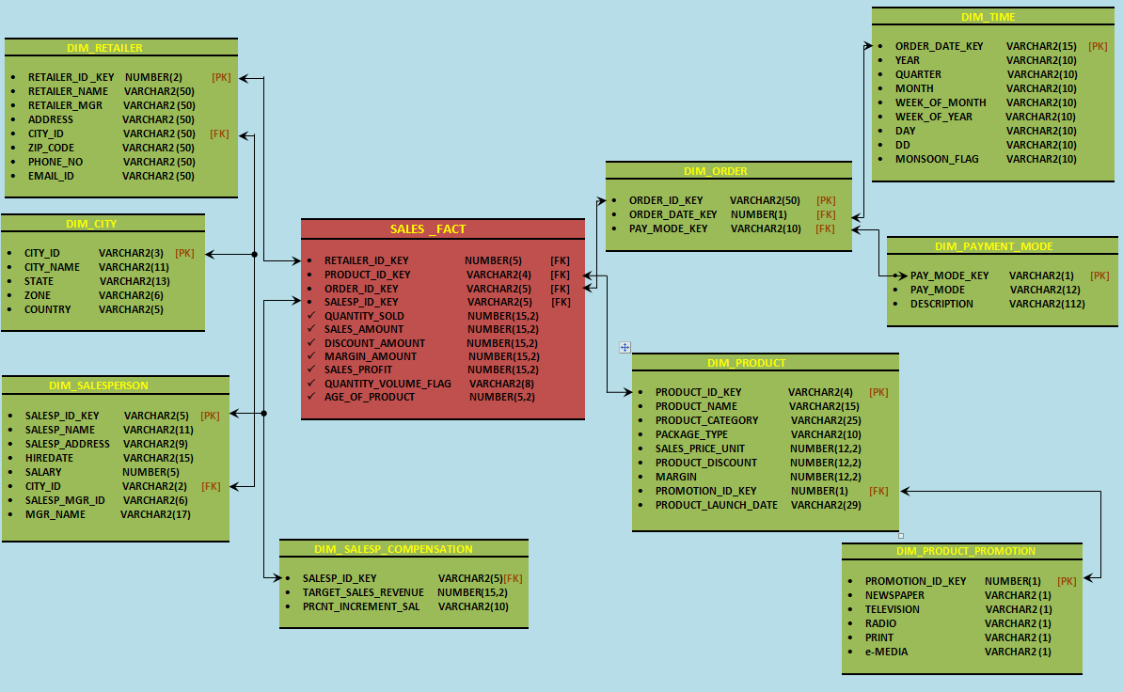**2. SCHEMA STRUCTURE:**

**3. REPORTING:**

1. Calculate the total sales profit in year 2008, 2009, 2010

2. List the details of Top 5 retailers with good performance.

3. Display the Quarterly sales of ANTRACOL 70 WP quantity per Retailer.

4. Find out the optimal promotion strategy for which media is working effectively by city wise

5. Enlist the salespersons details who performed best last 5 years.

6. List the top 10 worst performing products according to season. Analyse the data and provide fruitful conclusion.

7. Display the sales report which includes the salesperson details and product details based on

a) Weekly

b) Monthly

8. Create a report to analyze which product is doing good or bad according to the discount given.

9. Display the product details with promotion ID equal to 2 as well as the margin exceeds 15% in a sorted manner.

10. Highlight the top 5 salesperson details who got maximum increment in the current fiscal year

**5. RISK & ASSUMPTION:**

**Assumption:**

* There is no need to perform data cleansing.
* It is assumed that the data present in the database has been verified.

**Risk:**

* There can be NULL VALUES.
* There may be few repeated records.
* Values Can be of different data type.

# Revision History

|  |  |  |  |  |
| --- | --- | --- | --- | --- |
| **#** | **Date** | **Version #** | **Section/Page # changed** | **Details of changes made** |
| 1. | 03rd Nov, 2018 | V1.0 |  |  |
|  |  |  |  |  |